

CHEMISTRY 3A/3B

Solutions to

MAJOR TEST 4

CHAPTERS 9, 10

**TIME ALLOWED 60 minutes**

This test is made up of two sections

Section 1 contains 19 multiple choice questions worth 19 marks

Section 2 contains 6 questions worth 38 marks

Section 1 :

The following information refers to items 1 and 2:

The button cells used in hearing aids, watches and cameras is often the alkaline

silver oxide/zinc cells. When these cells are in operation the cell potential is 1.5 V and the overall cell reaction occurring is:



1. In the reaction above the change in oxidation number of the silver is:

A +1 to 0

B -1 to 0

C +2 to +1

D +2 to 0

E 0 to +1

2. In this button cell, zinc forms

A the cathode and is reduced

B the positive electrode and is oxidized

C the negative electrode and is reduced

D the negative electrode and is oxidized

3. The oxidation number of chromium in the compound, potassium chromate, K2CrO4 is:

A 7

B 6

C 4

D -2

4. Which one of the following species (atom or ion) would you expect to be the strongest oxidant ?

A Br -

B Ag+

C Pb2+

D Mg

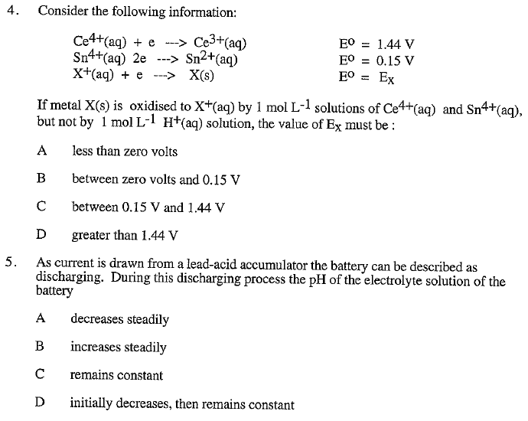

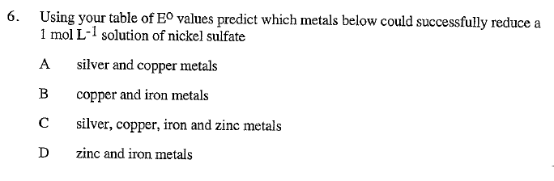

Answers:

4 B

5 B

6 D

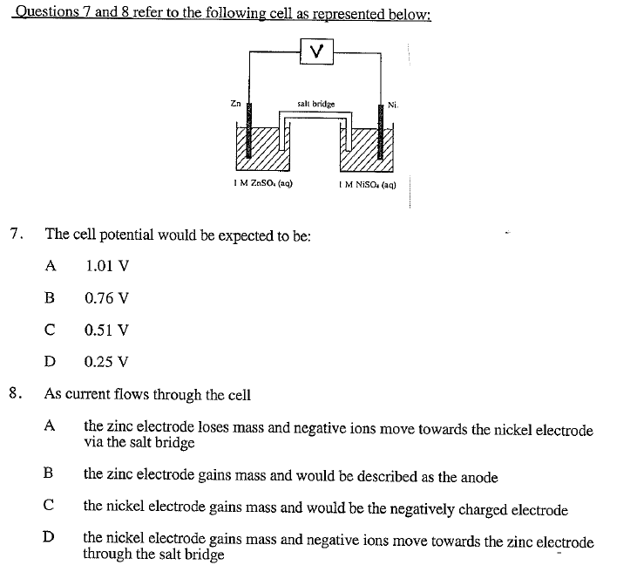

Answers:

7. C

8. D

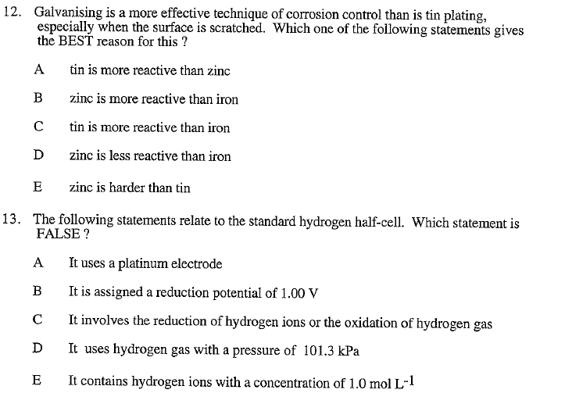

Answers:

12. B

13. B

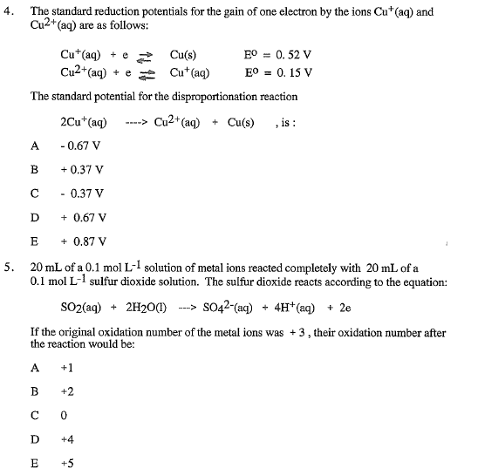

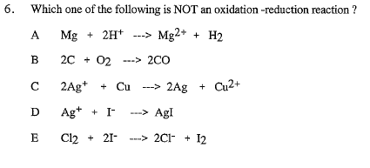

Answers:

4. B

5. A

6. D

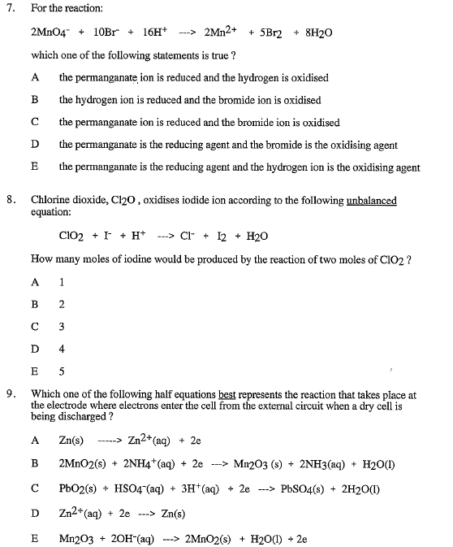

Answers:

7. C

8. E

9. B

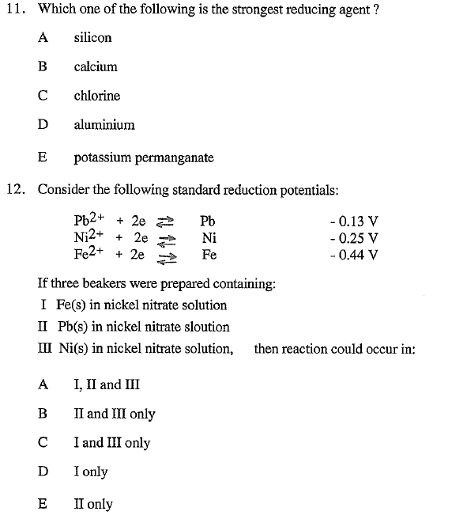

Answers:

11. B

12. D

